AWS day 1 task

Step1: Creating the instance in Mumbai region with my IP

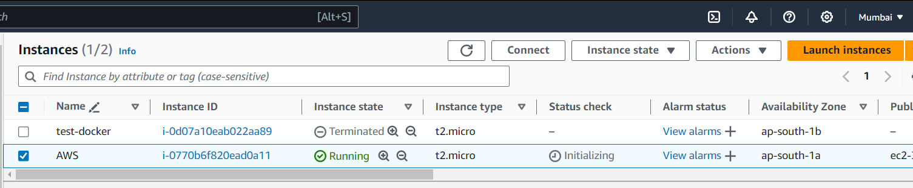  
  
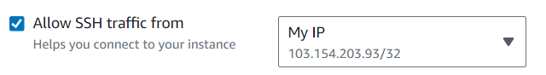

Step 2: Installing docker and docker compose

